OZONE Release Notes

OWF & the Store

December 10, 2013

Publication/Revision History

Release | Date
Initial Document – OZONE 7.6.0 | December 10, 2013

Contents

Release Notes 4
Installation Information 4
Upgrade Information 4
OZONE 7.6.0 Release Stories 5
Improvements to the Quick Listing View 5
Add Required Listings and Agency Association from the Create/Edit Listing Form 6
Additional Improvements 7

Release Notes

Installation Information
Directions on how to install OZONE are found in the Configuration Guides for OWF and the Store.

Upgrade Information
Instructions for upgrading from older versions of OZONE are found in the OWF and Store Configuration Guides’ Appendices. While database upgrade and create scripts exist for four database types, the OZONE quality assurance team only tests the MySQL database upgrade and create scripts.

OZONE 7.6.0 Release Stories
The OZONE 7.6.0 release adds enhancements to the Listing Quick View. Administrators and listing owners can now add more than two screenshots that expand when clicked and the Details tab provides more information that administrators can reorder. Also, this release added the Required Listings relationship to the Create/Edit Listing Form as well as giving listing owners the ability to associate their listings with agencies (a feature previously reserved for administrators). Find the complete and specific list of tasks and completed bugs at: https://www.owfgoss.org/jira/browse/OP. The following section highlights major changes.

Improvements to the Quick Listing View
The team enhanced the Quick Listing View. It now includes the ability to add more than two screenshots.
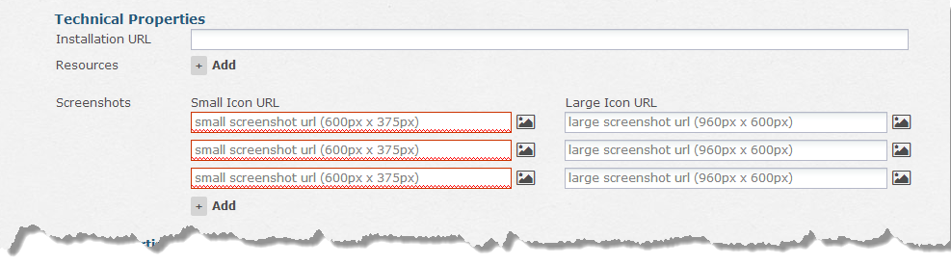
Figure 1: Adding screenshots on the Create/Edit Listing Form
Clicking the screenshots on the Listing Quick View expands the screenshots.
Note: If you’re using Internet Explorer, the X to close the expanded view appears in the browser.
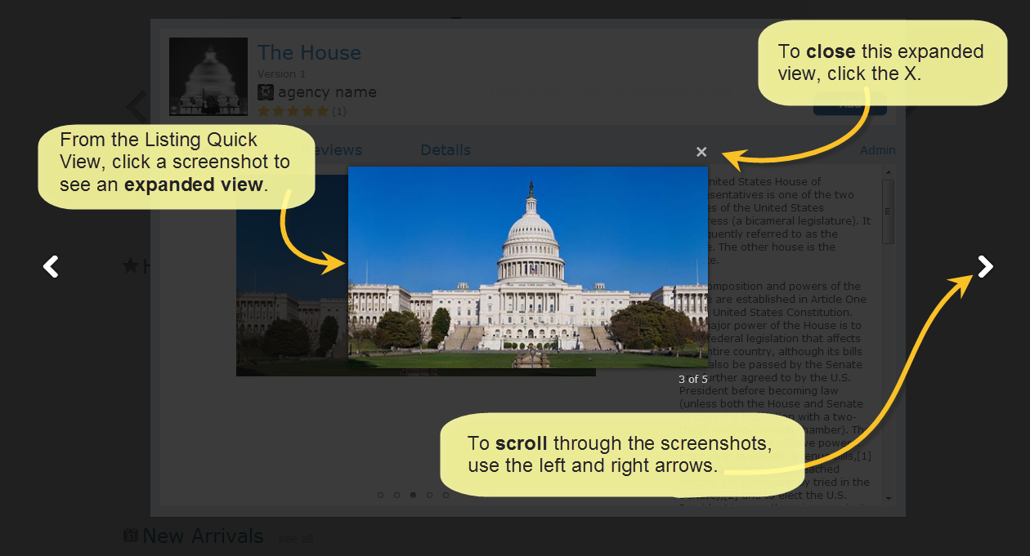
Figure 2: Expanded Screenshot View
The Details tab includes more information that administrators can reorder:
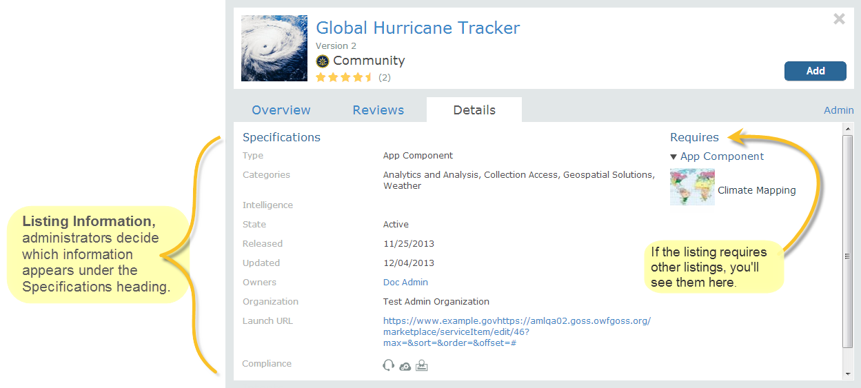
Figure 3: Revisions to the Listing Quick View Details tab

Add Required Listings and Agency Association from the Create/Edit Listing Form
Starting with OZONE 7.6.0 owners and administrators can add the “required” relationship between listings from the Create/Edit Listing Form. This streamlines the listing creation process and reduces the clicks needed to complete listing creation.
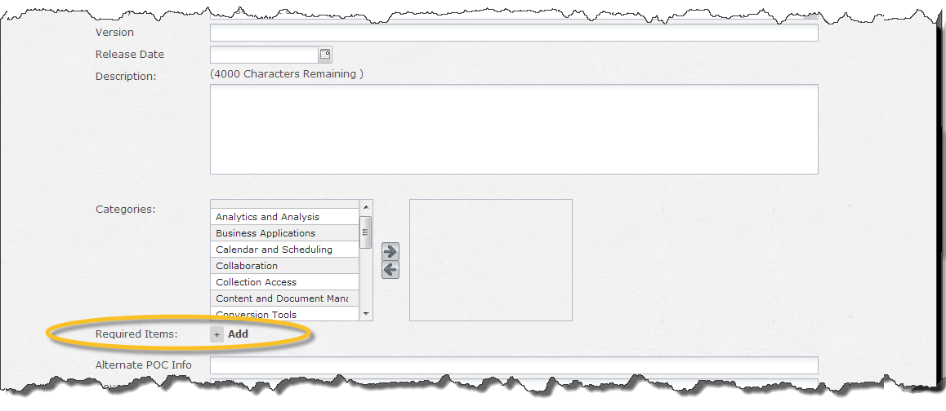
Figure 4: Adding Required Listings from the Create/Edit Listing Form
When OZONE added the Agency field, only administrators could associate listings with agencies. Now, any administrator and owner can add an agency association to a listing from the Create/Edit Listing Form.
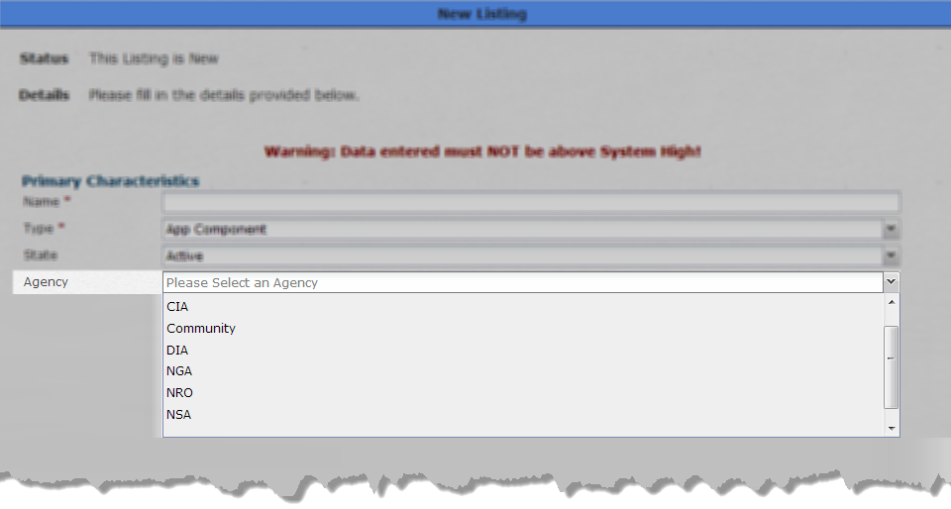
Figure 5: Adding Agency association on the Create/Edit Listing Form

Additional Improvements
- The Store will display JBlocks banner regardless if OWF is in the same browser.
- In efforts to prevent vulnerability to XSS, drop-down fields on the Create Listing Form are encoded as well as Custom fields and Type labels on the Listing Quick View Details tab and the Listing name on the Add Required Listings modal.

